March 15, 2021 CIT Mentor Forum “Chat”

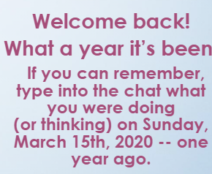 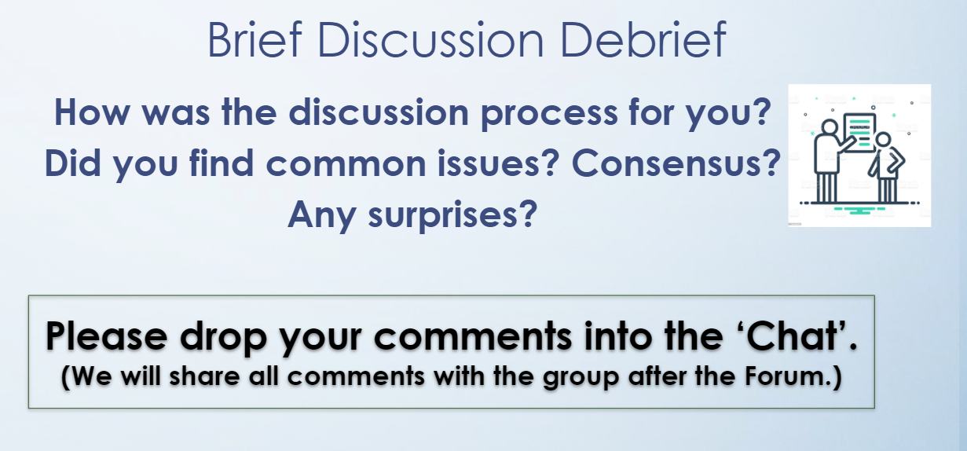

***Find Breakout Room “Discussion Debrief” chat comments by clicking*** ***here******.***

One year ago I was thinking: I wonder if school will be closed for one week or two weeks? WOW! Was I wrong!

that it would only take a week to get us back to school, maybe two

This won't last that long. We'll be back in school in a week.

Wow - A week off - I will finally have time to clean the house. #stillnotenoughtime

One year ago, I also was thinking "we will be back in school before NYS testing"

Wondering what exactly will be expected of us once the "smoke clears"

I agree.. I thought for sure we would be back to "normal" by spring break

2 weeks out of school seemed soooo long then:) I told my friends I was going to use this thing I heard about: zoom

I was thinking I would be able to catch up on things!

One year ago I was thinking... A week off, I am going to paint my kitchen. 😊

I was thinking that we would only be remote a month or two. Here we are a year later.

How in the world was I going to do library remotely?

One Year ago I was enjoying the thought of some extra vaca time at home with my daughter but very worried about what her last few months of her senior year were going to look like.

I was thinking it would be really nice to have my college kid home for a few weeks

I thought we might be out of school for 1-2 weeks max!

I was doing a lot of shopping. Needless to say, I haven't bought toilet paper since March 15, 2020.

I guess we will have a few days off of school. I wonder when baseball will be allowed to begin again.

How was I going to raise my mothers grandchildren everyday. No just kidding. Maybe.

I remember first hearing about local cases at Saturday School

I could never have guessed we'd be teaching remotely for such a long time!

Entering the twilight zone!

I was not only thinking we would be going back soon, but remember being grateful I had just gotten back from a cruise, and that the ship did not have to quarantine while out to sea, like some cruise lines did...

II was just so relieved that schools were closed!

I was at a Registrar PD at East High School.

I was trying to figure out the fastest way to get toilet paper to my son in Colorado who is in the military.

On Sunday March 15th, 2020 I was hoping to be released from the hospital. I was put on the Covid floor (quarantined) because I had just traveled back from having chemo in Boston on the 12th. I was one of the first people that were quarantined at Strong. I was not Covid positive, but having neutropenic fevers. I was able to go home on the 15th, but had to quarantine in my bedroom for 3 more days until my covid test came back negative! Certainly has been a crazy ride!! one year cancer free!!

Thinking that I better get a Shamrock Shake in case McDonalds shuts down!

That we’d be back to school after break.

When I was going to see my mom 83 yrs old in NYC and still unable to see her.

getting my motorhome packed so I could head to myrtle beach

I was setting up 3 school age stations for my daughters and one teacher station for me in our house.

1 year ago today...I can't believe this is really happening

I was thinking ‘this cannot be real’. We hardly get snow days off.

Driving home from Niagara Falls Canada

Trying to convince my son to cut his spring break short in Florida

I was thinking that we would be out of school for a couple of days only....

We went out to eat for my husband's birthday, his whole family cancelled on going, so just the three of us. There was one other table in the restaurant. The hostesses let my 3 year old daughter help them seat the one other party that came in. It was the last time I ate inside a restaurant.....

How am I going to teach Kindergarten remotely

I was thinking about making the lessons for the following week

celebrating my daughter's 5th birthday

I was thinking, "this won't last, we'll be back after Easter"



Yes we found common issues

I think we were mostly in agreement.

Shared experiences

Similar discussions and feelings

It was nice meeting with unfamiliar faces

Yes common perspectives and concerns

Lots of agreement

We were in agreement.

We agreed in our group as well. Found some positives.

We found some positives and some areas of growth.

Consensus

Format worked for collecting evidence and sharing

We had a good conversation in our group- discussed the similarities we found between in person and remote teaching.

It was great to see other teachers and how they were doing

We were in agreement

No real surprises. We agreed on pretty much everything

Common theme was flexibility

My group worked well and had good discussion

Our group seemed to be on the same page with much of this discussion. I would like to be in a group with colleagues similar to my tenure area again.

Definitely highlighted positives of lesson

We were all in agreement with a good level of engagement. Teacher kept students on task by asking questions.

Observing in person brings to light new things to focus on compared to the remote observations.

We felt that her "popcorning" technique was quite effective, especially with the countdown to give those kids a few seconds to gather themselves before they had to act.

Common themes, good discussion

Short wait time for responses from students. (Nature of remote learning) Worry about “dead time”.

The questions were not crafted for the responses she was looking for.

Definitely each of us in the group had common thoughts

My group had common thoughts and observations, but most were HS teachers so they had different perspectives.

Focused on the positive support the teacher showed good discussions

We all agreed that this teacher was consistently positive and enthusiastic and that resultd in her kids' engagement

Teacher kept enthusiasm throughout, students were engaged

I liked the randomness of the room- different subject area, etc. However, lots of commonalities

We had thoughtful reflections and comments. Some questions about what the previous lesson was and what the targets were for this lesson. She was positive and encouraging. Used wait time and rephrased one question in response to student reply.

We like the constant feedback to her student. She was positive and encouraging.

Good discussion about questioning in the ELL/ICOT environment

Lower level questions were plenty. Very positive and tried to keep kids engaged

Great lesson--common perspectives on rubric elements.